**Kol Simcha Torah Gazette**

**For parsha behar-bechukosai 5785**

Volume 9 Issue 34 (Whole #449) 26 Iyar 5785/ May 24, 2025

**Printed L’illuy nishmas Nechama bas R’ Noach, a”h**

For a free subscription, please forward your request to [***keren18@juno.com***](mailto:keren18@juno.com)

***Past emails can be found on the website ShabbosStories.com under Brooklyn Torah Gazette***

**From the Non-Jewish Nanny to the Now Jewish Nanny:**

**A Lesson for Each of Us**

**By Rabbi Efrem Goldberg**



***Rabbi Efrem Goldberg***

Adriana Fernandez had a unique path to social media fame. For years, her almost-90,0000 followers online have enjoyed her posts, pictures, and videos recollecting her insights and experiences as a non-Jewish nanny working in observant Jewish homes. She even adopted and leaned into her moniker, “Non-Jewish Nanny.”

It all began when she was a student studying opera in college when she took a job on the side babysitting. The first family that found her on the babysitting website was Jewish. Adriana didn’t have Jewish friends growing up and knew little about the Jewish people’s practices and lifestyle. As she began babysitting in observant Jewish homes, it quickly became much more than just a job or source of earning money. She came to not only love the children she interacted with but the lifestyle they and their families were leading.

She began to share her “non-Jewish” perspective and thoughts on Orthodox Jewish laws, traditions, and rituals, and it went viral. From insights and observations on tznius and shaitels to kosher recipes and Jewish holidays, people were enamored by her energy, positivity, and capacity to pronounce the “ch” sound.

As her following grew, kosher and Jewish businesses took notice, sending her clothing and other products to feature and promote. All the while, she continued to serve as a nanny in Orthodox Jewish homes, developing meaningful relationships with the families she cared for, particularly the children.

Online, people saw her following and influence grow. What they didn’t see was that offline, the influence of the families she was working for was growing on her. Adriana wasn’t just curious and intrigued by the Torah way of life, she began to want it for herself. Adriana approached a rabbi and rebbetzin in the neighborhood where she was working and they agreed to sponsor her in the geirus (conversion) process.

She took it seriously from the start, learning, reading, reviewing, studying the curriculum, attending davening and classes, and integrating among observant Jewish friends. (Every detail here is published with her permission.) When the Beis Din became involved, being an “influencer” didn’t accelerate her process; if anything, it made it go slowly, methodically and in a way that would build confidence this interest was genuine and not a way to grow her following or any other motivation.

While the change in her dress and her life was noticeable, Adriana never discussed her journey and process with her followers. She never announced the program she was in or what she was working towards. And finally, after a lot of work and patience, the day came. She immersed as Adriana and emerged as Adina Shoshana.

A few days after the birth of her new identity came the transformation of her online profile. The “Non-Jewish Nanny” became the “Now Jewish Nanny.” The Gemara (Yevamos 62a) teaches that ger she’nisgayeir k’kattan shenolad dami, one who converts is like a child that is born anew. But the language of the Gemara is puzzling. Shouldn’t it be a goy she’nisgayeir, a non-Jew who converts? Why do our rabbis phrase it as, “a convert who converts”?

The Chida (Midbar Kedemos) explains that Chazal were teaching that the conversion reveals that it wasn’t a non-Jew who converted, it was someone who was always destined to be Jewish, whose soul was also at Sinai. Ger she’nisgayeir, the would-be convert, converts. Adina Shoshana is the real deal: genuine, authentic, knowledgeable, spiritual, and Torah-observant. She should be admired and appreciated for her journey and encouraged and supported as she continues her next steps as a full- edged, proud, and practicing Jew. Her Rabbi and Rebbetzin deserve enormous credit for their guidance, care, and time teaching her how to live as a Jew. The Beis Din who enabled her to fulll her dream will forever now be tied to Adina like everyone they convert, getting credit for her mitzvos and also carrying a responsibility for any shortcomings.

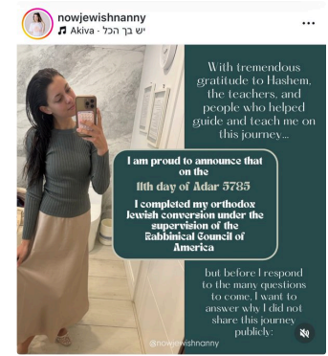

I share this story with you because it is fascinating and inspiring but also because I think there are other, unseen people in this story who deserve great credit and who obligate each of us. The families that Adina worked for live a Judaism, and interact with people around them, in a way that that someone who was working for them and living with them wanted be a Torah-observant Jew. That is extraordinary and a tremendous credit to them.

Adina shared that it was the children in particular—their sweetness, their patience in sharing their learning and lives with her, their joy in being and living Jewish—that most inspired her. An important lesson of the Now Jewish Nanny’s journey and the families that inspired her is to ask ourselves, if someone worked in our home, lived with our family, was involved in our lives and lifestyle, would that draw them closer to Judaism or push them away? Would it inspire them or turn them off? Would it make them want to be more like us or to have nothing to do with us?

The Talmud (Bava Metzia 59b) stresses that the Torah obligates us to love the convert and to refrain from causing anguish or pain no less than thirty-six times. But it isn’t only the convert we should treat well. All who work in our homes, and in whose places of work we frequent, Jew and non-Jew alike, will be impacted by how we behave in general and by our attitude towards our Judaism in particular.

When he was older, Rav Yisroel Salanter no longer baked his own matzah before Pesach, but rather he asked his students to bake his matzos for him. The students, knowing that baking matza is not always a simple process, asked him, “What are the Chumros (stringencies) the Rebbe makes sure to adhere to when he bakes matzah?”

He replied, “I am very careful not to yell at the woman who cleans up between every batch of matzah baking. She is a widow. Please speak kindly with her.”

We may not have asked to be role models or to be responsible for others’ impressions of Judaism, but we have been entrusted with this sacred mission, one we should embrace with pride rather than resentment. Not everyone we meet will go from Non-Jewish to Now Jewish, but if we live with positivity and joy, with honor and respect, they can go from “Never Liked Jews” to “Now Love Jews,” simply because of us.

*Reprinted from a recent blog by Rabbi Efrem Goldberg, Senior Rabbi of the Boca Raton Synagogue in Florida, the largest Orthodox Jewish house of prayer in the Southeast United States.*

**Rav Avigdor Miller on**

**Appreciating Whatever Torah**

**You Are Capable of Learning**

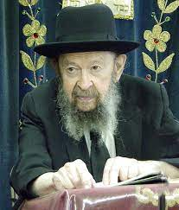

**QUESTION:** How can one talk himself out of his despair in knowing the Torah?

**ANSWER:** I suppose it means that he thinks that it’s too much for him to do and he gives up hope; he gives up hope of succeeding in knowing Torah.

And so, we’ll take an analogy. As you walk on Kings Highway, you see big establishments. There are some big businesses there, successful stores. But on one street corner, there’s a man with a peanut stand. It’s a simple cart; two wheels, that’s all, and there’s a little stove that’s heating the peanuts. And this man is standing there and waiting for customers.

Now, they’re not standing in line for him. Customers are few and far between. And sometimes it’s cold too. Does he give up? No. Why doesn’t he give up? Because he wants as much as he can earn. He can earn three dollars a day, five dollars a day, he’s satisfied.

Of course, he’d like to earn five thousand dollars a day but when it comes to money, however, you earn as much as you’re able. And he’s quite happy if he takes home five dollars at the end of the day. When it comes to learning, all of a sudden nobody wants to learn for peanuts. Everybody wants to be a millionaire.

“If I cannot be a gadol hador, then I don’t want to learn.” He gives up. I had a case like that. He said, “I can’t become a gadol so what’s the use?”

No! If you can learn one line a day it’s a success! You learn two lines? A bigger success! Learn whatever you can and that’s a great achievement. It’s only the yetzer hara that tells you either you learn for the highest stakes or don’t learn at all. It’s a deception and many people allow themselves to be persuaded by that. It’s remarkable how much people can accomplish if they learn little by little. In the course of time, it adds up to a great amount of wealth!

*Reprinted from a recent email of Toras Avigdor based on a Thursday night lecture delivered on March 20, 1980.*

**Maimonides on How the World Will**

**Be After the Coming of Moshiach**

**From the Teachings of the Lubavitcher Rebbe**

**Rabbi Menachem Mendel Schneerson, Zt”l**



At the end of his Laws of Kings, Maimonides writes: "One should not think that any aspect of the world will be altered in the Days of Moshiach... Rather, the world will continue to function in its usual manner." In other words, in the Messianic Era the world will still operate according to the laws of nature.

However, in the second of this week's two Torah portions, Bechukotai, we find two contradictions to this ruling. "And the tree of the field will give its fruit" - in the Messianic Era all trees, including non-fruiting bearing varieties, will yield fruit. This is obviously a departure from the laws of nature. In another verse, G-d promises "And I will remove evil beasts from the land" - wild animals will no longer be predatory. This also contradicts the way nature operates at present.

Maimonides himself explains the discrepancy: When the world was first created, all trees produced fruit. It wasn't until after the sin of the Tree of Knowledge, when Adam was punished with the decree of "Thorns also and thistles shall [the earth] bring forth to you," that some varieties of trees stopped producing fruit, and some animals became predatory. In the Days of Moshiach, the world will simply revert to its original character. According to Maimonides, this does not constitute a change in nature. True, the world will be different from the way it is now, but nonetheless "continue to function in its usual manner."

There are also several seeming contradictions in the Torah's description of how Moshiach will be revealed. In one instance the Torah tells us that Moshiach will arrive "on heavenly clouds" - in a supernatural manner - yet Moshiach is also depicted as "lowly and riding on a donkey." The first description relates to a situation in which the Jewish people will have "merit"; the second describes Moshiach's arrival "if they will not have merit." Likewise, the manner in which the Holy Temple in Jerusalem will be rebuilt also depends on whether or not the Jewish people will be worthy. With sufficient merit, the Third Holy Temple will descend from heaven completely erected. If they are less deserving, Moshiach will build it.

The fact that Moshiach will arrive is certain, regardless of our actions. The only variable is how the Final Redemption will take place. Because the Laws of Kings is a legal work, Maimonides gives us the "worst case" scenario, describing how Moshiach will come if the Jewish people will not have sufficient merit. The existence of Moshiach will not necessarily alter creation, "and the world will continue to function in its usual manner."

If, however, we will be worthy, Moshiach's arrival will be accompanied by many more revelations of G-dliness, as well as open miracles.

*Reprinted from the Behar-Bechukosai 5762/2002 edition of L’Chaim. Adapted from Volume 27 of Likutei Sichot.*

**More Thoughts that Count for Our Parsha**

*And these are the generations of Aaron and Moses...(*3:1)

Previous to this statement, only the sons of Aaron were mentioned. Why, then, were they also considered the generations-children-of Moses? Moses taught Torah to the children of Aaron; whoever teaches Torah to the children of his fellow-man, Scripture credits him as though they were his own children. *(Rashi)*

*Reprinted from the Behar-Bechukosai 5762/2002 edition of L’Chaim*

**Rabbi Berel Wein on Parshat B’har-Bechukotai 5785**

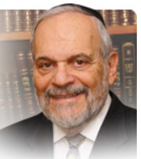

The book of Vayikra, which contains so many detailed commandments and minute  details of ritual within it, concludes with a broad view and general description of Jewish faith. It restates the original premise of Bereshith, that the earth and its inhabitants belong to G-d and are free agents as to the limits that G-d has imposed upon them. The basic premise is that “the earth belongs to Me.” All of the various laws of agriculture that apply in the Land of Israel are based on this simple declaration of the sovereignty of G-d over the domain where humans temporarily reside.

We storm about asserting our ownership and build for ourselves palaces as though we will be their eternal tenants. It is this false assessment of the true nature of life that leads to painful disagreements and dysfunction in families, communities and even in the relationship between countries and national entities. The power of self-grandeur unfortunately knows no bounds in the human psyche. The prophet mocks the Pharaoh of Egypt who evidently thought that he created and controlled the Nile River.

Our world is witness to tyrants who made and make themselves gods and ascribe to themselves the power to dominate the lives of millions, and to threaten the destruction of millions of others, who do not bow to their inflated will. The truth is that the closer one is able to come to godliness, so to speak, that person will become more-humble and recognize his or her true place and space in this world. And that is the secret of attaining humility and which is ascribed to our great teacher Moshe.,

The Torah also limits the control we have over of the lives of others. The L-rd informed the Jewish people that they are His servants. People have somehow convinced themselves that they truly are entitled to control the lives of others. Perhaps this arises from the necessity of parents to raise their children to adulthood. Yet the economic system that currently governs our lives allows little room for consideration of the needs of others. Human lives are unfortunately secondary to the almighty bottom- line and this affects the entire balance of society generally.

If we realize that we are all only G-d’s servants, that humbling effect should make life easier to deal with. The realization of the limits of human power is one of the basic lessons of Judaism. Of course, human beings are able to accomplish great things and this is the story of the advancement of human civilization throughout the millennia of history. It is the balance of this aspiration and the human drive for greatness coupled with the humble realization of our limitations, which the Torah wishes us to achieve.

Care and concern for others, an appreciation of G-d’s ownership of the earth and a belief in the guardianship of G-d over the land and its people are the key ingredients, in the Torah’s view, of the Jewish future. And that is a basic understanding of the lesson that the Torah and this week’s pasha teaches us.

Shabat shalom.

*Reprinted from the current website of rabbiwein.com*

**Thoughts that Count for Our Parsha**

*And G-d spoke to Moses in the wilderness of Sinai*...(Numbers 1:1)

G-d purposely chose a desert in which to give the Torah. He spoke to the Jews in a place where everyone enjoyed free access, to show us that every Jew has an equal obligation and share in the Torah. *(Bamidbar Rabba and Michilta B'Shalach)*

*Take the sum of all the congregation of the children of Israel, by their families, by their fathers' houses...*(1:2)

In order to know the number of people in each tribe, first they were counted according to their families and then each member of the family was counted. This shows us the importance of the family. The existence of the Jewish people is based on and dependant on the actions of each family. *(The Lubavitcher Rebbe)*

*Reprinted from the Behar-Bechukosai 5762/2002 edition of L’Chaim*

**The Cairo Geniza:**

**How a Dusty Attic Changed Jewish History Forever**

**By** [**Eliyahu Freedman**](https://aish.com/authors/eliyahu-freedman)

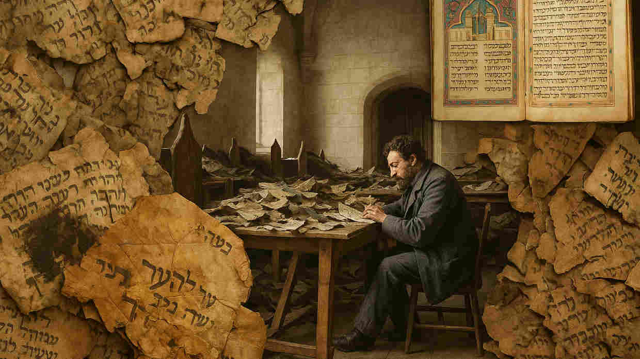

Solomon Schrechter at work in Cambridge University Library, studying the fragments of the Cairo Geniza, circa 1898

*A thousand years of daily life, debate, and devotion, preserved in a forgotten storeroom in Cairo is reshaping Jewish history.*

In 1896, in a forgotten storeroom above the ancient Ben Ezra Synagogue in Cairo, Jewish history changed forever.

The room was dark, dry, and filled with dust—and also with nearly 400,000 fragments made of paper and parchment that had remained untouched for centuries, preserved by Egypt's arid climate. When scholars, notably Solomon Schechter of Cambridge University, first began sorting through this treasure, they unearthed something profound—a time capsule preserving nearly a thousand years of continuous Jewish life and rare texts previously thought to be extinct.

**What is a Geniza and**

**Why is This One So Special?**

A *geniza* comes from the Hebrew word meaning "to store away" or "to hide." In Jewish tradition, texts containing G-d's name cannot be casually discarded. Instead, such holy items are temporarily stored in a dedicated space—a *geniza*—until they can receive a proper burial in a cemetery, similar to how a human body is treated with the utmost respect.

What makes the Cairo Geniza uniquely valuable for historians is that the community not only allowed centuries of traditional *geniza* materials to accumulate without burial—prayer books, worn-out Torah scrolls, and religious texts—but also included more mundane materials that Jewish law doesn't require to be ceremonially discarded: grocery shopping lists, personal letters, bills of sale, tax documents, and even children's practice sheets learning to write the Hebrew alphabet.

The end result is one of history's most comprehensive archives of the medieval world, providing a window into a sophisticated Mediterranean society where Jewish merchants negotiated trade contracts across vast distances from Andalusia to Yemen, scholars debated the finer points of philosophy in Arabic and Hebrew, women engaged in business and legal matters, and much more.

**A Window into Medieval Jewish Life**

The Cairo Geniza paints a vibrant portrait of what scholar S.D. Goitein aptly named "A Mediterranean Society" in his monumental six-volume work. Far from depicting Jews as an isolated, persecuted minority, the Geniza documents reveal them as integral participants in a sophisticated medieval world.

Through business correspondence and legal documents, we see Jewish merchants establishing trade networks spanning from Spain to India, dealing in everything from spices and textiles to books and precious metals. These papers show Jews, Muslims, and Christians regularly forming business partnerships, sharing knowledge, and participating in a complex economic ecosystem that transcended religious boundaries.

The Geniza reveals a medieval Mediterranean world characterized by mobility and cultural exchange. Jewish traders spoke multiple languages, adapted to local customs in different ports, and maintained connections across vast distances through sophisticated networks of communication and credit.

These documents challenge our modern assumptions about medieval society, showing instead a cosmopolitan civilization where diverse communities lived and worked together, creating a multicultural tapestry that rivals the richness and complexity of our globalized world today.

**Personal Stories**

Some of the most invaluable treasures from the Geniza are the dozens of personal letters of medieval Jews who describe their joys, sorrows, and daily concerns in their own handwriting.

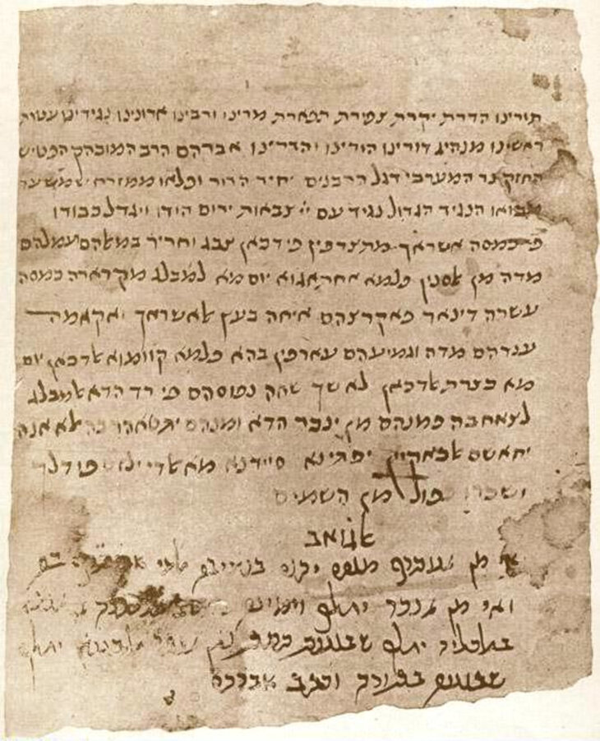

***A letter signed by Abraham, the son of Maimonides***

One such poignant fragment is a heartbreaking letter written by the towering figure of Medieval Judaism, Maimonides, who mourned his brother David who drowned while on a trading voyage to India. "The greatest misfortune that befell me during my entire life," Maimonides wrote, describing how he remained "bedridden with fever and despair" for a year following the tragedy.

Other documents written in Maimonides' own hand include the first editions of his works complete with personal edits, revisions, and margin notes, providing unprecedented insights into how the brilliant thinker developed his ideas. Some of these precious documents can be viewed today at the National Library of Israel in Jerusalem.

The Geniza also illuminates the lives of women, preserving evidence of their active roles in medieval society. Letters show women conducting independent business transactions, managing property, and advocating for their rights in religious courts. One fascinating document records a woman authorizing her representative to arrange her divorce and negotiate the financial settlement—evidence that women exercised significant legal agency in matters affecting their lives.

**Rediscovering Lost Texts**

What makes the Cairo Geniza genuinely unparalleled is how it preserved texts once thought lost forever. Among its most significant discoveries is the Damascus Document, an ancient Jewish sectarian manuscript previously known only through medieval copies but later found among the Dead Sea Scrolls. The Geniza's fragment predates the Dead Sea Scroll version by centuries.

Similarly, it contained the original Hebrew text of Ben Sira (Ecclesiasticus), a wisdom book composed around 180 BCE that had vanished from Jewish tradition for nearly a millennium.

The Geniza also revealed unexpected cultural connections that challenge our assumptions about medieval religious boundaries. Researchers uncovered fragments of Arabic translations of Jewish texts owned by Muslims, and Jewish-owned copies of Islamic philosophical works. Perhaps most surprisingly, some documents show Jews studying and engaging with the Qur'an for academic purposes.

Other fragments include Jewish adaptations of popular Arabic poetry and literature, showing how Jews participated in broader cultural currents while maintaining their distinct identity. One fragment even contains a Jewish merchant's notes on Buddhist customs he encountered while traveling to India, demonstrating how the medieval Mediterranean world was connected to civilizations far beyond its shores.

**Why the Cairo Geniza Matters Today**

Over a century after its discovery, the Cairo Geniza continues to transform our understanding of Jewish history. Digital projects at Princeton and [Cambridge](https://cudl.lib.cam.ac.uk/collections/genizah/1) are making high-resolution images of these fragments accessible worldwide, allowing both scholars and casual history enthusiasts to examine documents that were once accessible only to specialized academics. Thanks to these initiatives and online databases where anyone can browse thousands of digitized fragments, the Geniza is becoming less the domain of ivory tower scholars and increasingly a resource for anyone with a passion for Jewish history.

Perhaps most importantly, as these ancient fragments become more accessible in our digital age, the Geniza reminds us that everyday matters—shopping lists and love letters can reveal as much about humanity as grand historical narratives. It offers a profound lesson: every word has weight, and even the smallest scrap of Jewish life, preserved with care, can illuminate entire worlds.

The Jews of medieval Cairo never imagined their dusty attic would one day inspire generations, but in preserving even mundane aspects of Jewish life, they performed a sacred act of memory that continues to enlighten us today.

*Reprinted from the current website of aish.com*

**Dynamic Duo Celebrates 15**

**Years of Learning Together**

**With “Partners in Torah”**

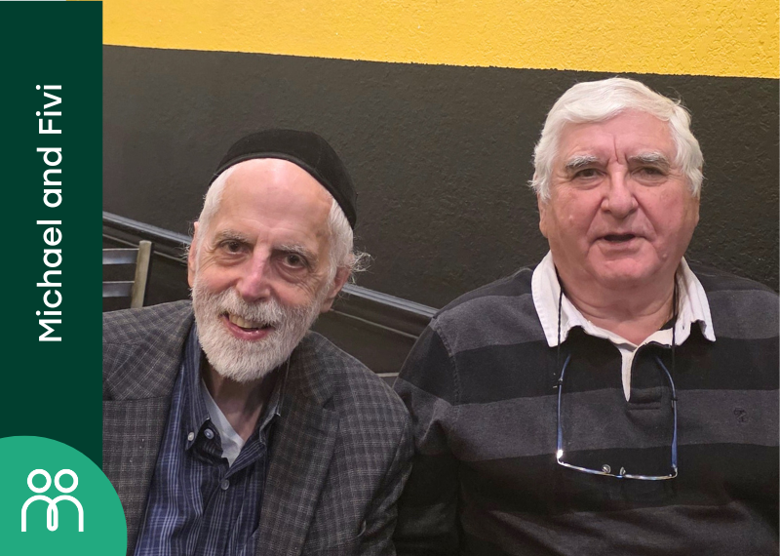

A 15th learning versary is quite the milestone! We are so glad that Michael Gelb (Woodmere, NY) and Fivi Block (Brookyn, NY) were able to celebrate their decade and a half of learning over a delicious meal in a Kosher restaurant!

Mike and Fivi are currently learning Understanding Judaism by Rabbi Mordechai Katz. Although they don’t live too far from each other, the two only met in person once before, when Mike had gone to Brooklyn. They were so happy to get together and enjoyed connecting over food (even though they certainly enjoy connecting over Torah!). Mike and Fivi were matched together by Partners in Torah.

*Reprinted from the Parshat Emor 5785 email of Partners in Torah.*